BiConsumer Functional Interface:

java.util.function package has lot of Functional Interface.
It will accept only 2 parameters and returns nothing. It has only one abstract method and one defaut method andThen

package com.java8;

import java.util.HashMap;
import java.util.Map;
import java.util.function.BiConsumer;

public class BiConsumerFunctionalInterface {

public static void main(String[] args) {

Map<Integer, String> m = new HashMap<>();
m.put(1,"A"); m.put(1, "B");m.put(3, "C");m.put(4, "D");m.put(5, "E");m.put(6, "F");m.put(7, "G");

BiConsumer<Integer, String> biconsumer = (k,v)-> System.out.println("Key : "+k+"\t Value : "+v); // this is the implementation of BiConsumer behavior which will be used to iterate the foreach loop.
m.forEach(biconsumer);

}

}

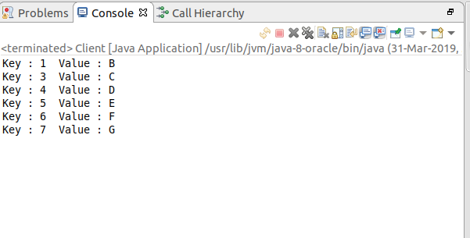

Instead of implementing the BiConsumer interface separately, we can directly do it in the forEach loop.

package com.java8;

import java.util.HashMap;
import java.util.Map;
import java.util.function.BiConsumer;

import com.java8.model.Student;

public class BiConsumerFunctionalInterface {

public static void main(String[] args) {

Map<Integer, Student> stuMap = new HashMap<>();
stuMap.put(1, new Student("Soumya",7501680600L));
stuMap.put(2, new Student("Soumya",9100920183L));
stuMap.put(3, new Student("Kuhelika",9153367262L));
stuMap.put(4, new Student("Sudeshna",9153466192L));

stuMap.forEach((k,v)->System.out.println("Key : "+k+"\tValue : "+v));
}

}

Student.java

package com.java8.model;

public class Student {

private String name;
private Long phoneNo;
public Student(String name, Long phoneNo) {
super();
this.name = name;
this.phoneNo = phoneNo;
}
@Override
public String toString() {
return "Student [name=" + name + ", phoneNo=" + phoneNo + "]";
}

}

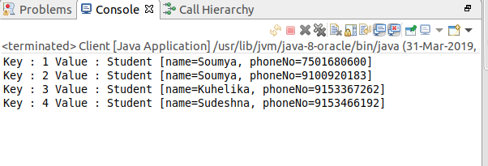

BiFunctionFunctionalInterface:

It accepts only 2 parameters and returns one type. And ha osnly one abstract method.

R BiFunction<T t, U u>

import java.util.function.BiFunction;

public class BiFunctionFunctionalInterface {

public static void main(String[] args) {

BiFunction<Integer, Integer, String> biFunction = (num1, num2)-> "Result is : "+(num1+num2);
System.out.println(biFunction.apply(100, 50));

}

}

Result is : 150

BiPredicateFunctionalInterface :

it has one method called test which is accepting 2 parameters and return type is boolean.

package com.java8;

import java.util.function.BiPredicate;

public class BiPredicateFunctionalInterface {

public static void main(String[] args) {

BiPredicate< Integer, String> biPredicate = (input1, input2) -> input1 > 20 && input2.startsWith("S");
System.out.println(biPredicate.test(30, "Martin"));
System.out.println(biPredicate.test(40, "Sheaper"));
System.out.println(biPredicate.test(10, "Seans"));

}

}

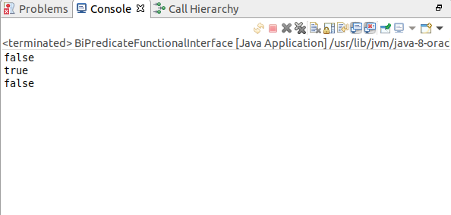

Function Functional Interface:

package com.java8.model;

import java.util.function.Function;

public class Employee {

private String name;
private int age;
public String getName() {
return name;
}
public void setName(String name) {
this.name = name;
}
public int getAge() {
return age;
}
public void setAge(int age) {
this.age = age;
}

public Employee(String name, int age) {
super();
this.name = name;
this.age = age;
}
/*@Override
public String toString() {
return "Employee [name=" + name + ", age=" + age + "]";
}*/
public String customShow(Function<Employee, String> function) {
return function.apply(this);
}
}

package com.java8;

import java.util.Arrays;
import java.util.List;
import java.util.function.Function;

import com.java8.model.Employee;

public class FunctionFunctionalInterface {

public static void main(String[] args) {

List<Employee> empList = Arrays.asList(new Employee("Soumya",27), new Employee("Sudeshna", 29), new Employee("XYZ",13));
//empList.forEach(emp -> emp.customShow(emp.getName()+"\t"+emp.getAge()));
for(Employee emp : empList) {
System.out.println(emp.customShow(e -> e.getName()+"\t"+e.getAge()));
}

System.out.println("-------------------------------------------------");

Function<Employee, String> function = emp -> {
String result = "Name : "+emp.getName()+"\tAge : "+emp.getAge();
return result;
};
empList.forEach(s -> System.out.println(s.customShow(function)));

}

}

